# CS 255 System Design Document Template

## UML Diagrams

### UML Use Case Diagram

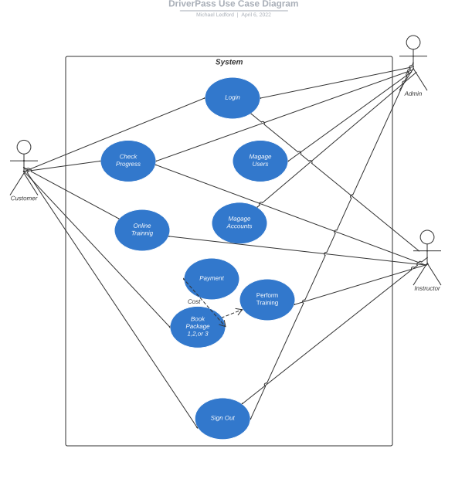

### UML Activity Diagrams

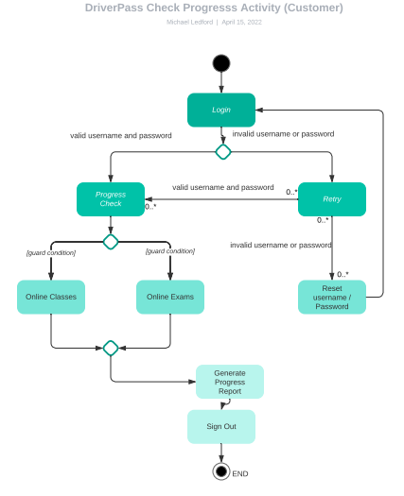

### 

### UML Sequence Diagram

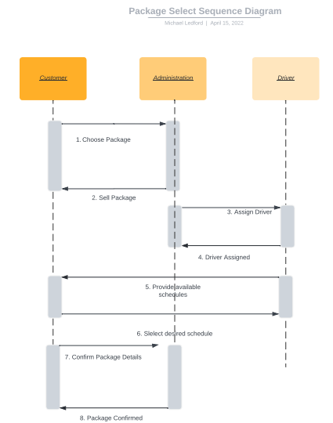

### UML Class Diagram

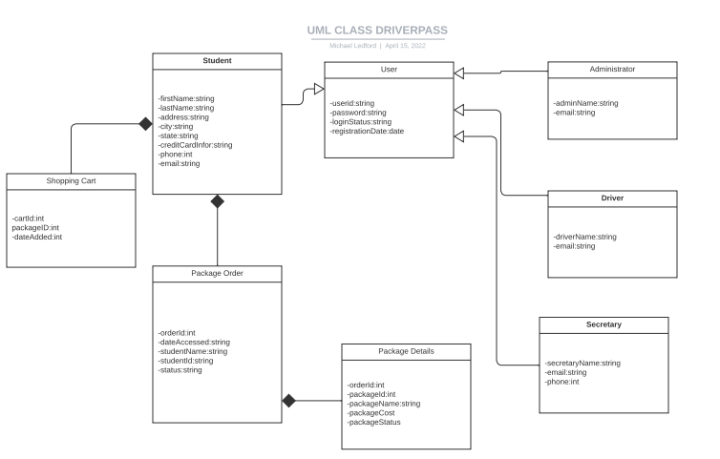

## Technical Requirements

*Based on the diagrams presented above, there will be technical requirements. For one, a high-speed internet connection will be necessary in order to facilitate online learning. Payments for available packages can be made either by phone or online. The student needs access to a computer, the ability to navigate course environments available through the system, and the ability to create and monitor system account information, including progress checks, grades, schedules, and updates. Administration requires internet access and the ability to monitor system activity. Additionally, the admin requires to ability to change/modify learning modules. Also, the admin requires the ability to disable packages to prevent additional registration. Staff and secretary will require the ability to reserve appointments via phone. In order to facilitate this function, internet access and login credentials will be required with the ability to create a user account for the student who is registering for a package. The driver/instructor will require access to an automobile for in-person training. Additionally, the driver/instructor will require a computer, internet access, and an active user account in order to facilitate training, grading, and feedback to the student/s who are registered to their class. Account access for the instructor will also allow for monitoring progress from the student.*